Carry out experiment to create VM on Linux Platform and check its working in the Server.

Login to the Azure account and click on to “Create a resource” button.

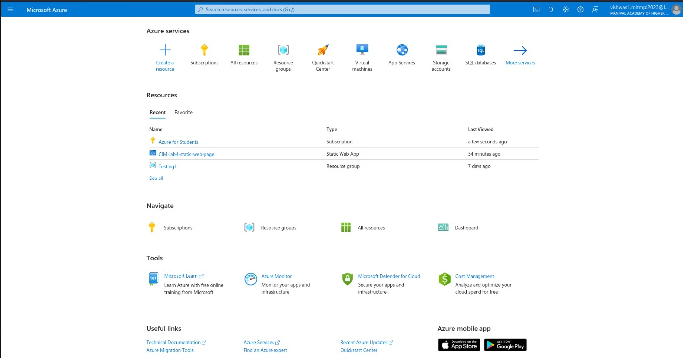

Search for the Virtual Machine and click on “create”

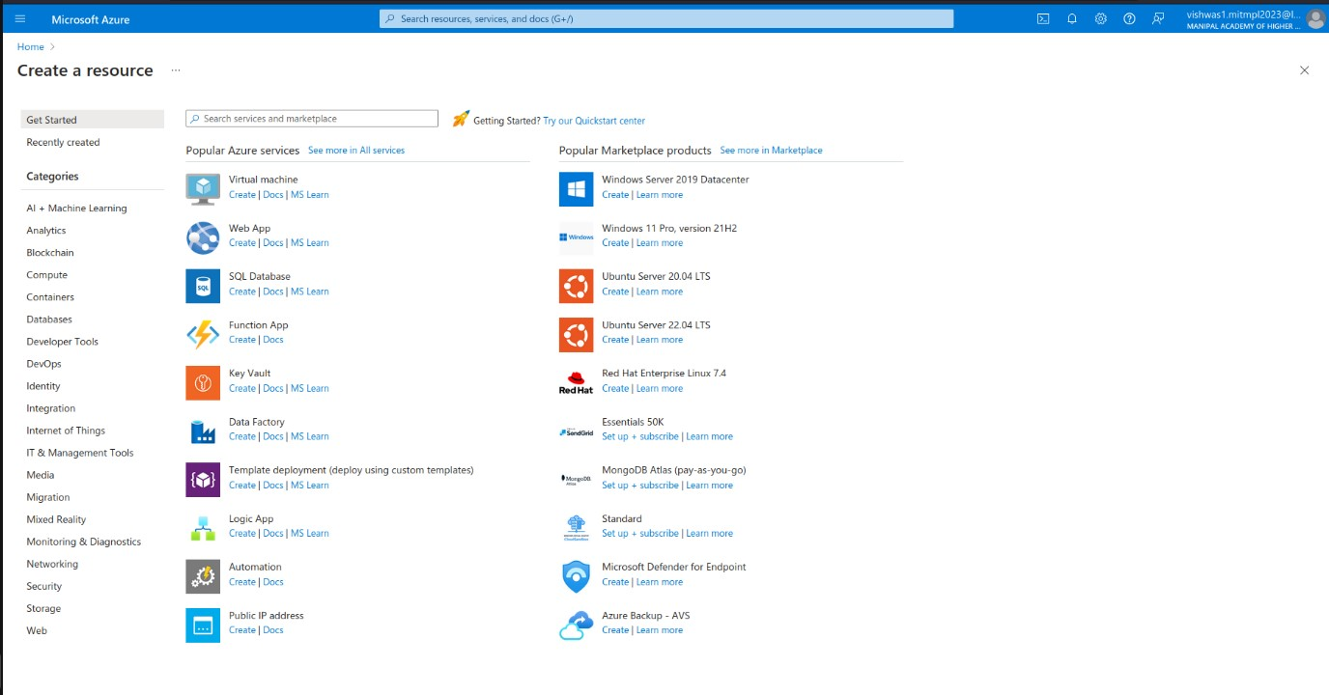

Give the suitable information for the virtual machine and choose and image file for the virtual machine

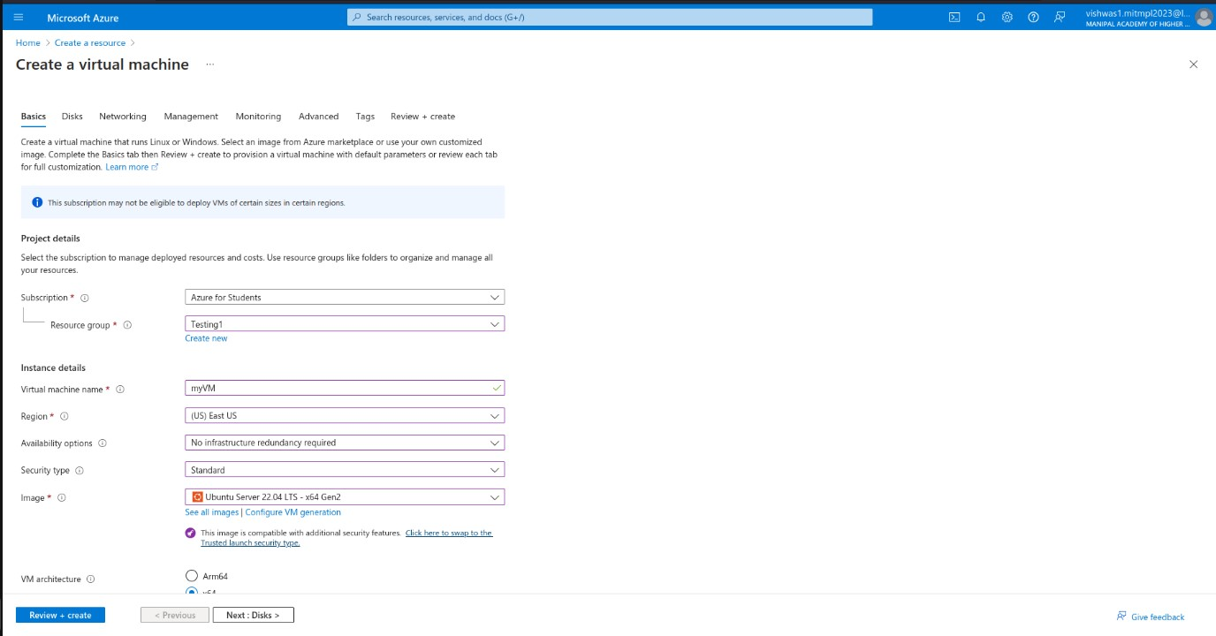

Click on “Create and Review” button.

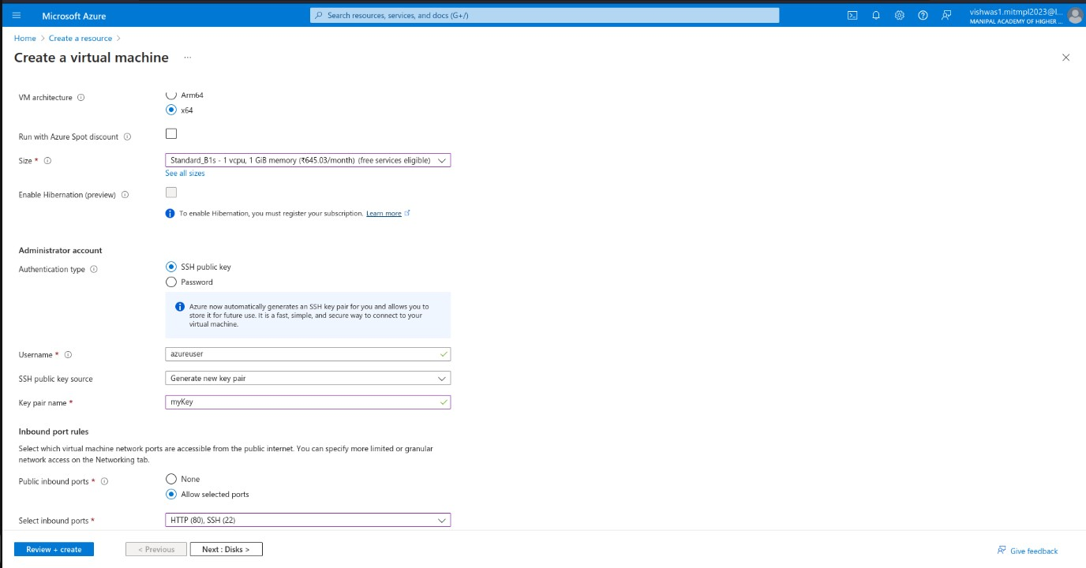

After successful of validation, click on “create” button.

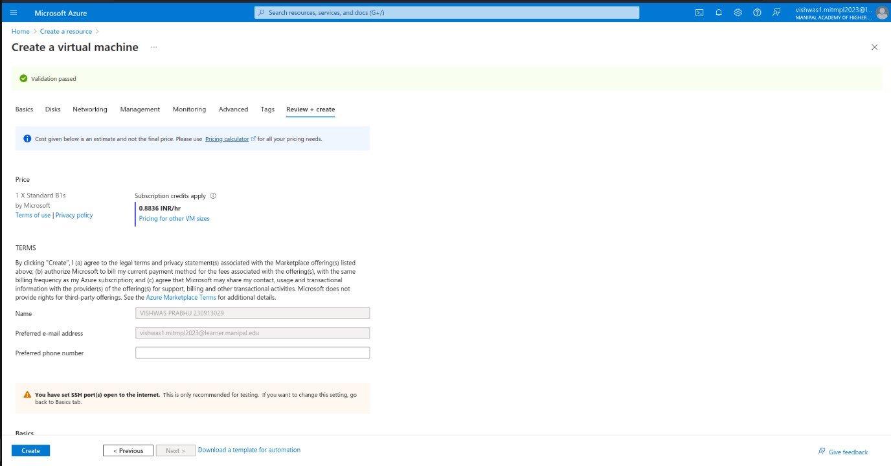

It will ask you for the Generation of new Key, click on “Download private key and create resource”

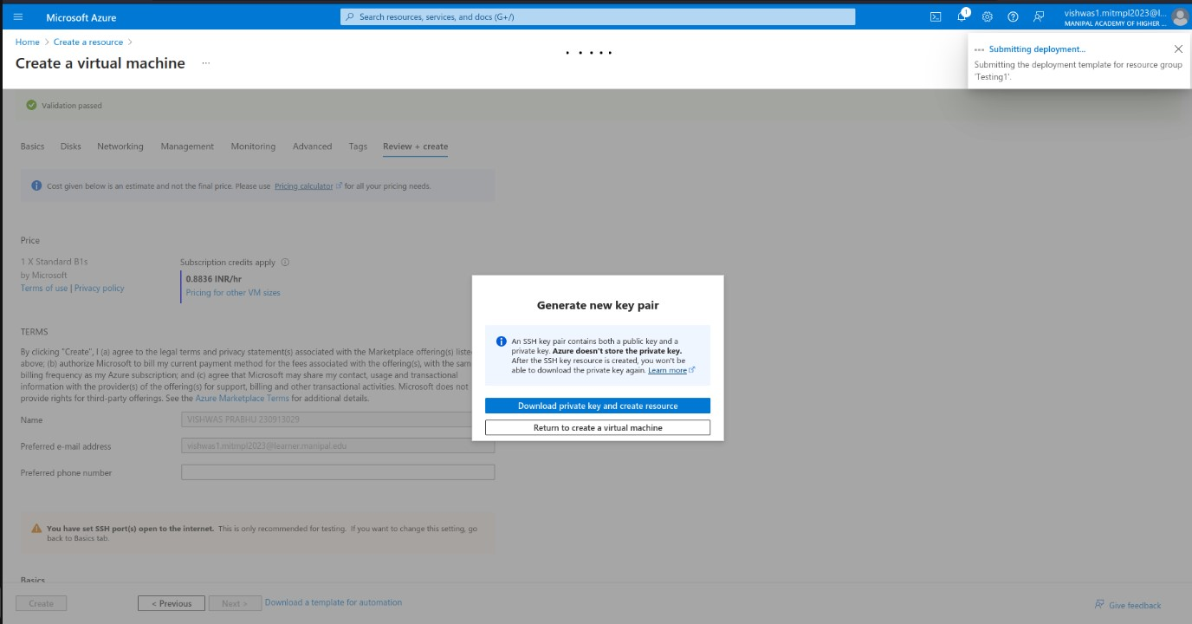

After successful creation of virtual machine click on “Goto resource”

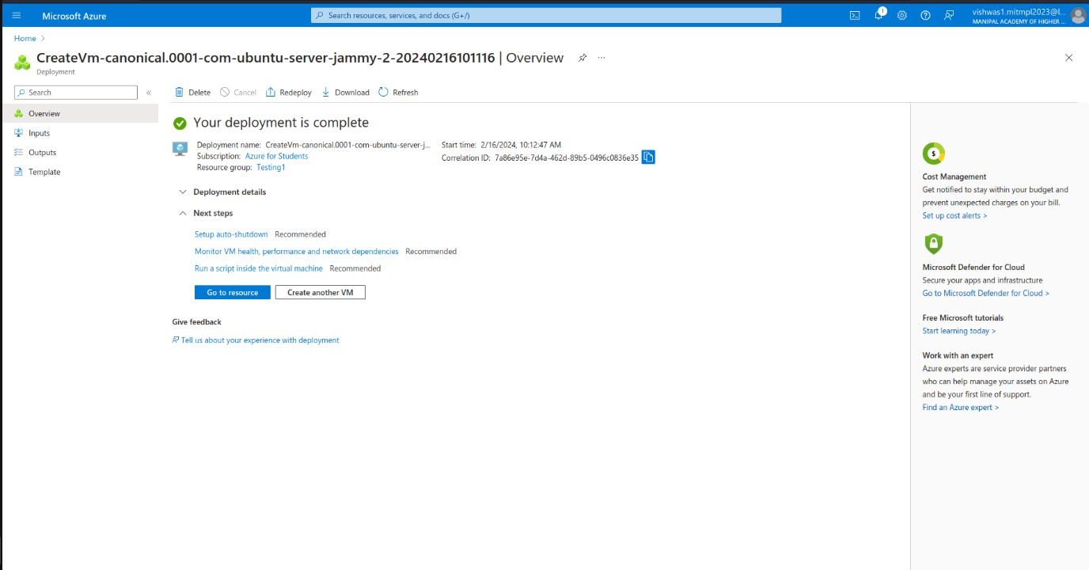

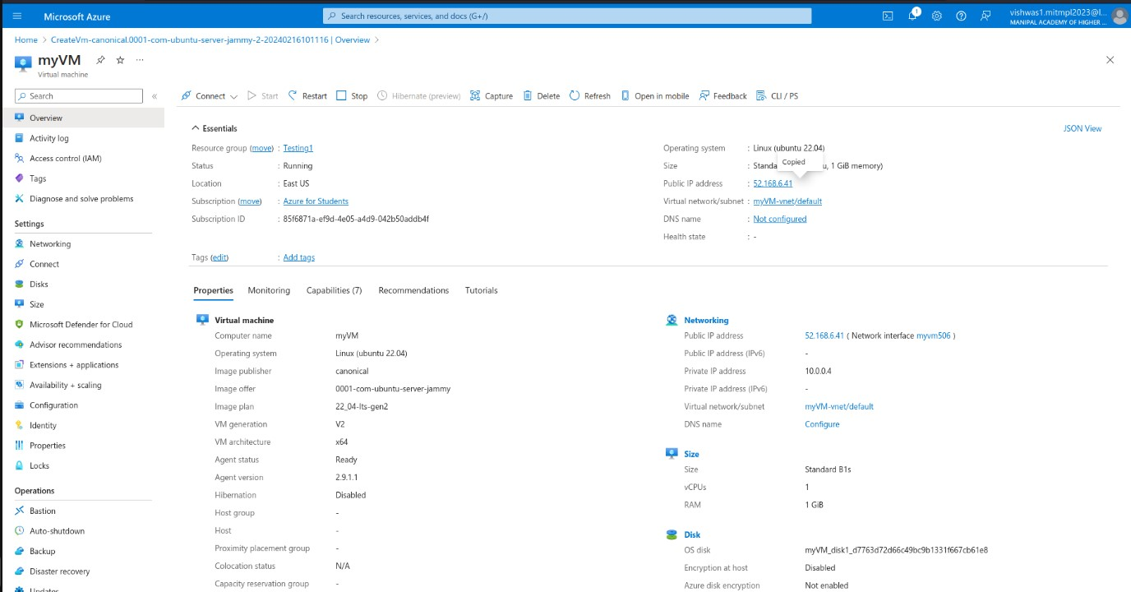

Come back to Azure, click on connect button and it will pop up the window for authentication, Then it will open the terminal

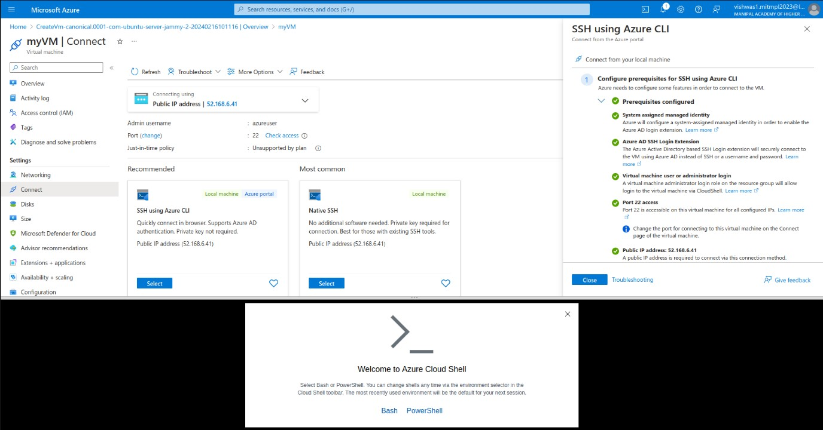

Choose the subscription in the terminal shown below.

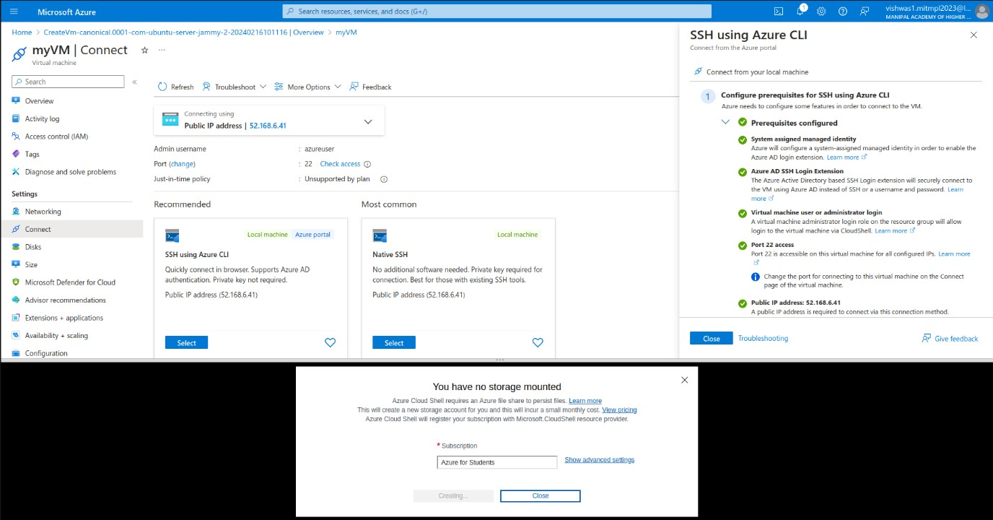

It will start the terminal.

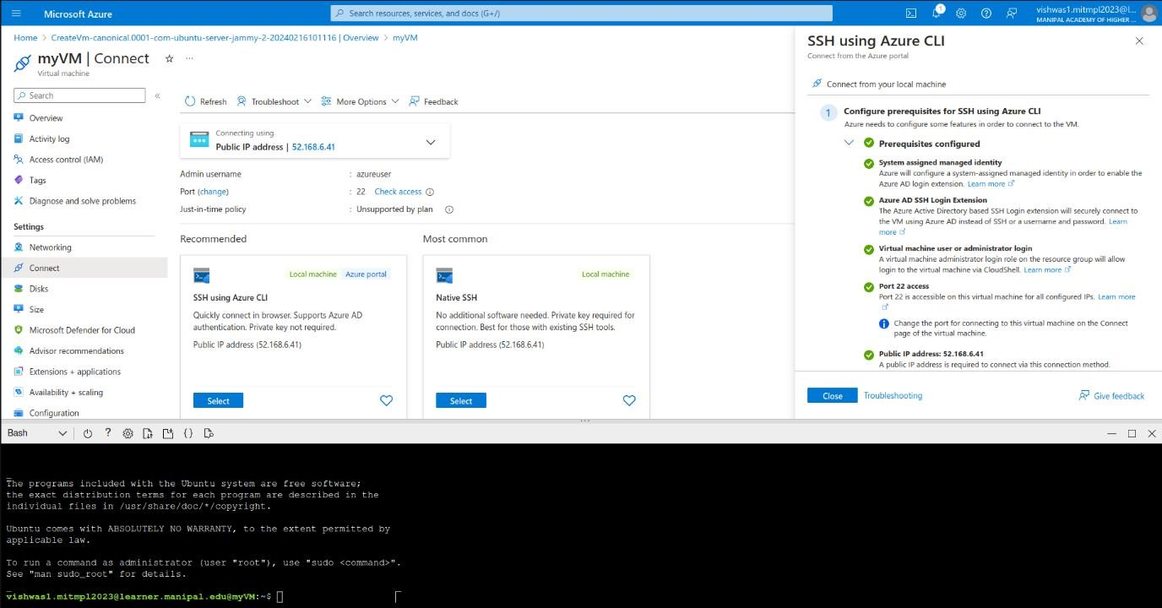

Enter the given command to update and install the certain packages.

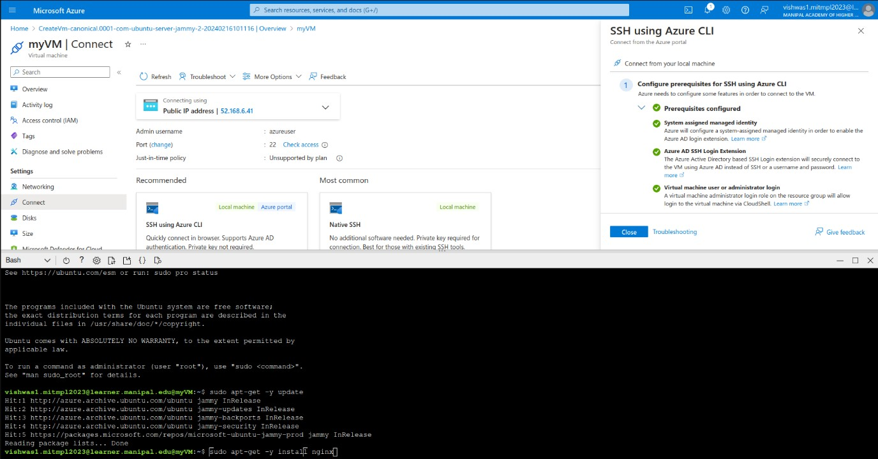

After the successful execution of the commands copy up the public ip address which is provided in the overview section of the virtual machine.

This is the result which is opted when we run the ip address.

